Task 1

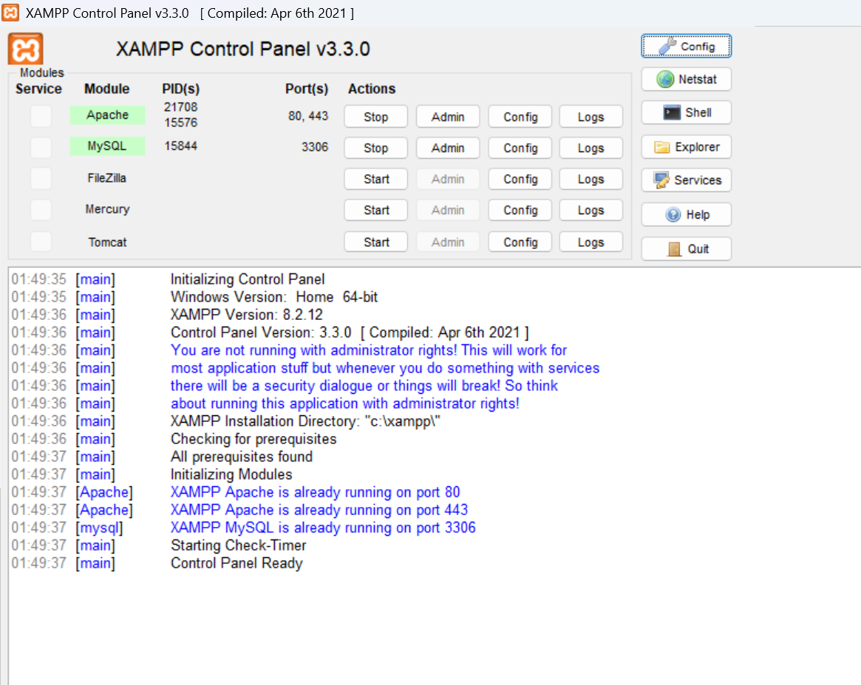
Task 2
CREATE DATABASE music_streaming_db;

Task 3
CREATE DATABASE food_delivery_db;

Task 4
-- TASK 4: Differences between MySQL and PostgreSQL

1. MySQL is widely used for web applications and is known
- for simplicity and good performance.
- PostgreSQL is known for advanced SQL features and complex queries.

2. PostgreSQL supports advanced data types and extensibility,
- while MySQL generally focuses on simplicity and ease of use.

3. PostgreSQL is commonly used for complex analytical,
geospatial, and enterprise applications.
- MySQL is widely used for websites and web applications.

Example of a company using MySQL:
Facebook ,
Youtube,
Netflix

Example of a company using PostgreSQL:
Instagram,
Spotify,
Amazon

